# ODD+D protocol of the Credibility enhancing display (CRED) agent-based model.

|  |  |  |  |  |  |  |  |
| --- | --- | --- | --- | --- | --- | --- | --- |
| 1. Overview | | I.i Purpose | | I.i.a What is the purpose of the study? | | To explore the conditions under which religious beliefs increase or decrease in artificial societies designed to represent a contemporary Western city. | |
| I.i.b For whom is the model designed? | | For social scientists and cognitive scientists, particularly those interested in the dynamics of natural versus supernatural beliefs | |
| I.ii Entities, state variables and scales | | I.ii.a What kinds of entities are in the model? | | * Human agents (either in majority group or minority group) * Religious clubs; agents may affiliate to specific clubs * Employers: entities providing job positions to human agents * Neighborhoods: human agents’ living locations | |
| I.ii.b By what attributes (i.e. state variables and parameters) are these entities characterized? | | Humans:   1. Age 2. Agreeableness 3. Charisma 4. Conscientiousness 5. Education, current 6. Education, total 7. Emotionality 8. Employer 9. Employer location 10. Existential Security 11. Extraversion 12. Frustration 13. Gender 14. Generation 15. Group 16. Honesty 17. Hypocrisy threshold 18. Income class 19. Income equivalized 20. Income individual 21. Income when last employed 22. In group support 23. Joining threshold 24. Level of Authority 25. Life Expectancy 26. Living location 27. Marital status 28. Memory of past creds 29. My children 30. Nativity 31. Occupation status 32. Openness 33. Out group suspicion 34. Pluralism index 35. Religion 36. Shared norms 37. Susceptibility 38. Total number of children 39. World View 40. Club affiliated to 41. Leader of a club   Religious Clubs:   1. Cost 2. Currently affiliated 3. Initial size 4. Leader 5. Location 6. Religion type   Employers:   1. Currently employed 2. Location 3. Minority Friendly 4. Number of job positions   Global variables:   1. After marrying, probability of wife joining the club of his husband, if husband is in a club (min marriages) 2. After marrying, probability of agents remaining same situation (dis)affiliated to(from) a club (maj marriages) 3. After marrying, probability of agents remaining same situation (dis)affiliated to(from) a club (maj/min marriages) 4. After marrying, probability of agents remaining same situation (dis)affiliated to(from) a club (min marriages) 5. After marrying, probability of husband disaffiliating from his club, if wife is in no club (maj marriages) 6. After marrying, probability of husband disaffiliating from his club, if wife is in no club (maj/min marriages) 7. After marrying, probability of husband disaffiliating from his club, if wife is in no club (min marriages) 8. After marrying, probability of husband joining the club of her wife, if wife is in a club (maj marriages) 9. After marrying, probability of husband joining the club of her wife, if wife is in a club (maj/min marriages) 10. After marrying, probability of husband joining the club of her wife, if wife is in a club (min marriages) 11. After marrying, probability of wife disaffiliating from her club, if husband is in no club (maj marriages) 12. After marrying, probability of wife disaffiliating from her club, if husband is in no club (maj/min marriages) 13. After marrying, probability of wife disaffiliating from her club, if husband is in no club (min marriages) 14. After marrying, probability of wife joining the club of his husband, if husband is in a club (maj marriages) 15. After marrying, probability of wife joining the club of his husband, if husband is in a club (maj/min marriages) 16. After marrying, probability of wife joining the club of his husband, if husband is in a club (min marriages) 17. Agreeableness heritability 18. Agreeableness mean 19. Agreeableness standard deviation 20. Authority impact 21. Conscientiousness heritability 22. Conscientiousness mean 23. Conscientiousness standard deviation 24. Curve shape factor determining probability of interpreting a CRED as a CRUD 25. Curve shape factor determining the probability of joining a religious club when holding a secular world view 26. Curve shape factor determining the relation between conscientiousness and CRED consistency 27. Curve shape factor determining the relation between values of frustration and CRED consistency 28. Curve shape factor for club and agent world view consistency 29. Dampening effect of the leader of a club on the increase of an agent’s frustration 30. Effect of being affiliated to a club on CRED impact 31. Effect of leader’s charisma on the CRED impact 32. Emotionality Heritability 33. Emotionality Mean 34. Emotionality SD 35. Endogamy Degree 36. Enforced Antidiscrimination 37. Error of display consistency of credibility enhancing display (CRED) 38. Extraversion Heritability 39. Extraversion Mean 40. Extraversion SD 41. Family Impact on Pluralism Index 42. Frustration Mode 43. Frustration range 44. Honest Heritability 45. Honesty Mean 46. Honesty SD 47. Human Development Index 48. Impersonal Radius 49. Importance of a CRED being display by a leader of a given club 50. Importance of a CRED being display by a leader of my club 51. Importance of a CRED being display by a religious agent 52. Importance of a CRED being display by a secular agent 53. Income Median In Hundred Thousands 54. Income Min In Hundred Thousands 55. Income Skew In Hundred Thousands 56. Ingroup Support Majority Mean 57. Ingroup Support Majority SD 58. Ingroup Support Minority Mean 59. Ingroup Support Minority SD 60. Interaction Radius 61. Limit of the sigmoidal curve determining consistency of club / world view of agent (eq. XX) 62. Marriage Age Tolerance 63. Marriage Conversion Rate 64. Marriage Education Tolerance 65. Marriage Rate 66. Max life expectancy majority 67. Max life expectancy minority 68. Max Number Of Children per couple 69. Max years of education majority 70. Max years of education minority 71. Memory Decay Rate 72. Min Age Marriage Majority 73. Min Age Marriage Minority 74. Min age to become leader of a club 75. Min Hypocrisy Threshold 76. Min Join Threshold 77. Min life expectancy majority 78. Min life expectancy minority 79. Min years of education majority 80. Min years of education minority 81. Minimum Club Cost 82. Minority Friendly mode 83. Nativity Cutoff 84. Number of adults in initial population 85. Number of clubs from majority 86. Number of clubs from minority 87. Number of Employers 88. Openness Heritability 89. Openness Mean 90. Openness SD 91. Out group suspicion maj mean 92. Out group suspicion maj SD 93. Out group suspicion min mean 94. Out group suspicion min sd 95. Percentage of agents from the majority group in population 96. Percentage of Female agents 97. Percentage of females from the majority employed 98. Percentage of females from the minority employed 99. Percentage of males from the majority employed 100. Percentage of males from the minority employed 101. Percentage of population not affiliated to a religious club 102. Probability of children joining the club (no club) of the mother 103. Probability of losing employment majority 104. Probability of Meeting leader of my club 105. Probability of sudden death (before life expectancy) 106. Shared Norms Mean 107. Shared Norms SD | |
| I.ii.c What are the exogenous factors / drivers of the model? | | ***Existential security:*** depends on the income class of the agent, human development index of the society, and perceived threat (degree of shared norms relative to outgroup suspicion). Existential security may attenuate or enhance the intensity of credibility enhancing displays (CREDs) shown by others.  ***Pluralism:*** a measurement of the variability of the worldview value of the agent in comparison with the average worldview values of its family and neighborhood. Pluralism may attenuate the intensity of the CRED display by others.  Club affiliation: being affiliated to a club enhances the intensity of the CRED display by the agent. | |
| I.ii.d If applicable, how is space included in the model? | | Explicit, georeferenced (GIS) | |
| I.ii.e What are the temporal and spatial resolutions and extents of the model? | | Weekly time steps; simulations are run for a finite number of years (user specified). One year is equal to 52 weeks. | |
| I.iii Process overview and scheduling | | I.iii.a What entity does what, and in what order? | | ***Weekly events (every time step).***  Agents hold interactions with others within their social networks. There are two types of weekly interactions, those affecting the integration variables (“integration interactions”) and those affecting the worldview variable (“CRED interactions”). Integration interactions occur within the agent’s: a) family, b) neighborhood, c) impersonal, d) online, e) offline and f) work social networks. CRED interactions occur within the agent’s: a) family, b) offline, and c) club social networks. After CRED interactions agents may (re)affiliate/disaffiliate from their clubs.  ***Monthly events (every 4 time steps).***  Agents in the working force may obtain/lose their jobs every month.  ***Annual events (every 52 time steps).***  Agents age by one year; and may die if they meet their life expectancy or from a sudden death (global variable 105). Otherwise they increase their education by one year. If their total education is reached, they enter the workforce and look for a job. If meeting the minimum age, they may get married and, if already married, they may get children. Finally, they update their offline and online social networks by adding or removing agents from them.  Then, the whole cycle starts again. | |
| 1. Design Concepts | | II.i Theoretical and Empirical Background | | II.i.a Which general concepts, theories or hypotheses are underlying the model’s design at the system level or at the level(s) of the submodel(s) (apart from the decision model)? What is the link to complexity and the purpose of the model? | | The main theories shaping the model’s design, especially the dynamics influencing agents’ worldviews, are credibility enhancing display (CRED) theory (Henrich, 2009; Lanman, 2012), existential security theory (Norris and Inglehart, 2004; Inglehart and Weltzel, 2005), and religious pluralism theory (Stark, 1994; Innaccone, 1998). CRED theory argues that being exposed to religious behavioral displays that are costly to those performing them will tend to increase an individual’s religious belief or affiliation. Existential security theory argues that increased social and economic development in a context will decrease religiosity of the population. Religious pluralism argues that when there is a wide variety of “suppliers” in the religious market, religiosity will diminish in the population. The dynamics of the integration variables are based on the research and theoretical work of David Voas (2009, 2014). The demographic structure of agents (age, education, employment, income, human-development index, marriage, intermarriage, number of children, etc.) was adjusted according to demographic statistics from the city of London. | |
| II.i.b On what assumptions is/are the agents’ decision model(s) based? | | All of the employers’, clubs’, and agents’ decisions are based on heuristics. | |
| II.i.c Why is /are certain decision model(s) chosen? | | All decisions are based on real-world heuristics. For instance, agents need to meet certain homophily conditions to get married and these conditions were obtained from demographic data. Similarly, the heuristics regarding the decision whether to join or leave a club are based on subject-matter expert assessments. | |
| II.i.d If the model / submodel (e.g. the decision model) is based on empirical data, where do the data come from? | | Statistical census. | |
| II.i.e At which level of aggregation were the data available? | | At the individual level, household level, and majority (host) / minority (migratory) group levels.. | |
| II.ii Individual Decision Making | | II.ii.a What are the subjects and objects of the decision-making? On which level of aggregation is decision-making modelled? Are multiple levels of decision making included? | | Employers make decision regarding the number of employees and the number of positions available to employees from the minority group.  Clubs make decision regarding the leader of the club.  Human agents make choices regarding marriage, children, and joining or leaving a club. | |
| II.ii.b What is the basic rationality behind agent decision-making in the model? Do agents pursue an explicit objective or have other success criteria? | | Agents pursue an education, finding a job, getting married, and having children. However, these are all side processes of the main goal of the model, which is investigating the conditions given rise to secular or religious societies. In this regard, agents do not pursue any specific secular or religious value. Instead they are subjects of CRED displays from others which may ultimately affect their worldview values. The evaluation of the CRED display follows a heuristic (decision tree), which is outlined in Figs 7 and 8.  Similarly, the effect of integration interactions follows a decision tree that depends on the type of interaction (see decision tree, Fig 1) | |
| II.ii.c How do agents make their decisions? | | Demographic decisions such as marriage and children follow a heuristic combined with stochasticity. Regarding the effect of displays on their integration and worldview values, they follow different decision trees depending on the type of interaction (see decision trees, figs: 1,7-8). | |
| II.ii.d Do the agents adapt their behaviour to changing endogenous and exogenous state variables? And if yes, how? | | Yes, the intensity of a CRED display may depend, among other things, on whether the agent is affiliated to a religious club and on whether the agent is the leader of a club. Similarly, the intensity with which an agent receives a CRED from another agent may be attenuated or enhanced by the effects of existential security, pluralism and charisma of the leader of the club (only when agent is affiliated). During the integration interactions, the effect of the interaction on the values of the integration variables depends on type (family, work, neighborhood, etc. -see decision tree, fig 1) | |
| II.ii.e Do social norms or cultural values play a role in the decision-making process? | | Yes, the value of shared norms (a proxy for shared cultural values) and outgroup suspicion affect the outcome of the integration interactions (fig 1) and the value of existential security perceived by the agent. | |
| II.ii.f Do spatial aspects play a role in the decision process? | | No. | |
| II.ii.g Do temporal aspects play a role in the decision process? | | Yes – the intensity of a perceived CRED depends on the age of the agent receiving the CRED as well as on the age of the agent emitting it. Young agents are more susceptible to CREDs, reaching a maximum at 25 years old and then decreasing. After 50 years old, agents are not affected by CREDS anymore. The age difference between the receiver and sender also plays a role on the intensity of the CRED. The younger the sender relative to the age of the receiver, the lower the intensity of the CRED display. | |
|  | |  | | II.ii.h To which extent and how is uncertainty included in the agents’ decision rules? | | The outcome of the integration interactions has a degree of stochasticity. Namely, the index in question is compared to random number draw from uniform distributions. If the index is lower or higher than the random number, the outcome may be positive or negative (see decision tree, fig 1).  The consistency element of the CRED display has a certain degree of stochasticity. In this case, values are drawn from a triangular distribution with mode = to the consistency index +/- error. The higher the error, the higher the uncertainty of the consistency value.  The decision of joining a club has a degree of uncertainty when agents hold a secular worldview. In the model there are only religious club. Thus, when the threshold for joining a club has been surpassed, agents holding a secular worldview may join a religious club. The probability of joining a club follows an exponential distribution where the closer the secular worldview value to the religious worldview value threshold the higher the probability that the agent decides to join religious club. |
| II.iii Learning | | II.iii.a Is individual learning included in the decision process? How do individuals change their decision rules over time as consequence of their experience? | | No, no learning process is included. However, the intensity with which individuals perceived a CRED display from others changes with the age of the receiver. |
| II.iii.b Is collective learning implemented in the model? | | No. |
| II.iv Individual Sensing | | II.iv.a What endogenous and exogenous state variables are individuals assumed to sense and consider in their decisions? Is the sensing process erroneous? | | Individuals perceive a threat from their neighborhood. This threat relates to the calculation of an index that takes into account the average neighborhood values of shared norms and outgroup suspicion. Similarly, agents perceived the degree of pluralism within their family and neighborhood. This index is calculated by the agent comparing its worldview value with the average worldview value of its family and neighborhood. Perceived threat and pluralism indexes may attenuate or enhance the intensity of the CRED displays.  Further, during integration interactions, agents perceived the overall value of shared norms, outgroup suspicion and ingroup support of the whole society and of its group (majority or minority).  Agents are also aware of all their endogenous variables. Important for decision making are the worldview and frustration variables. Worldview affects the way individuals consider the display of others (see decision trees, fig 7-8). Frustration determines if agents leave and/or (re)join club. If frustration of an agent surpasses a specific threshold, they leave their club (if affiliated) and/or look to (re)affiliate to a new club. Further, agents have a memory of the previous highest display of others and the club this agent was affiliated to. Thus, when agents decide to (re)affiliate to a club, they choose the one from which they perceived the highest display in past interactions. Memory, though, decays with time.  The sensing process is not erroneous. |
| II.iv.b What state variables of which other individuals can an individual perceive? Is the sensing process erroneous? | | Agents are aware of worldview (religious or secular), shared norms, ingroup support and outgroup suspicion values of others. They are also aware of whether others are affiliated to a club, and if so, to what kind of club (religious majority or religious minority club). When they are affiliated to a club, they can also perceive the charisma of the leader of their club. Regarding the demographic variables, agents are aware of the age, education, gender, marital status, and group (majority or minority) of others. |
| II.iv.c What is the spatial scale of sensing? | | Global (society, and group identity), local (individual). |
| II.iv.d Are the mechanisms by which agents obtain information modelled explicitly, or are individuals simply assumed to know these variables? | | The calculation of perceived threat and pluralism are updated every week. The thresholds to categorize agents’ income class are updated every two years. All other variables are just known by the agents. |
| II.iv.e Are the costs for cognition and the costs for gathering information explicitly included in the model? | | No. |
| II.v Individual Prediction | | II.v.a Which data do the agents use to predict future conditions? | | Agents do not make predictions on future conditions. |
| II.v.b What internal models are agents assumed to use to estimate future conditions or consequences of their decisions? | | No specific models. |
| II.v.c Might agents be erroneous in the prediction process, and how is it implemented? | | N/A. |
| II.vi Interaction | | II.vi.a Are interactions among agents and entities assumed as direct or indirect? | | They are assumed to be direct. |
| II.vi.b On what do the interactions depend? | | Agents’ interactions are dyadic and occur within their social networks. According to the social network, they depend on:   1. Family: whether they have a family or not 2. Online social network: individuals within their network 3. Offline social network: based on proximity, closer agents are more likely to be within this network 4. Work: depends on whether the individual is employed 5. Neighborhood: depend on the neighborhood the agent lives 6. Impersonal: depends on the value of a distance radius, agents within this radius are potential interaction partners 7. Club: depends on whether the agent is affiliated to a club |
| II.vi.c If the interactions involve communication, how are such communications represented? | | For CRED interactions, one individual sends a display (CRED) and the other receives this display.  For integration interactions, individuals communicate their group identity (minority or majority group). |
| II.vi.d If a coordination network exists, how does it affect the agent behaviour? Is the structure of the network imposed or emergent? | | Networks affect indirectly the agent behavior. Agents interact with individuals within their networks and this dyadic interaction may change the value of their worldview, frustration, shared norms, ingroup support and outgroup suspicion variables, which may ultimately affect the agent behavior.  All network structures are emergent except the family networks. |
| II.vii Collectives | | II.vii.a Do the individuals form or belong to aggregations that affect and are affected by the individuals? Are these aggregations imposed by the modeller or do they emerge during the simulation? | | Yes, agents have living locations, work locations, and clubs. These aggregations are partially imposed and partially emergent. Living location is dependent on work location (or partner work location if the agent is married), and work location depends on whether agents obtain or not a job, a process with a certain degree of stochasticity. Similarly, agents may join or leave clubs, which clubs they leave or join is not imposed but emerges from the agents decisions. |
| II.vii.b How are collectives represented? | | The number of neighborhoods is constant in all simulations. The number employers or clubs is predefined at the start of the simulation. The neighborhood location of employers and clubs is randomly assigned at initialization. |
| II.viii Heteroge­neity | | II.viii.a Are the agents heterogeneous? If yes, which state variables and/or processes differ between the agents? | | Agents are heterogenous for all their variables (1-41 in box I.ii). |
| II.viii.b Are the agents heterogeneous in their decision-making? If yes, which decision models or decision objects differ between the agents? | | Regarding integration interactions, the decision-making and update of variables are heterogenous according to group identity (majority/minority). Within each group, decision-making and update of variables is homogenous (see decision tree, fig 1).  Regarding CRED interactions, agents are heterogenous in their decision depending on the sender and their worldview values, and on their affiliation and sender affiliation (see decision trees, figs 7-8). |
| II.ix Stochasticity | | II.ix.a What processes (including initialisation) are modelled by assuming they are random or partly random? | | The consistency element of the cred display is assumed to have a degree of uncertainty (error).  Affiliating to a club when holding a secular worldview also depends on a stochastic process, with higher likelihood of joining the club when the secular worldview value is low.  Regarding integration interactions, a certain degree of uncertainty is placed when agents compare average indexes values to random numbers (see decision tree, fig 1).  At initialization, the following variables are drawn from normal (mean and standard deviation set by modeler), or uniform (range set by modeler) distributions:  **Human agents**: Age, Agreeableness, Conscientiousness, Education, total, Emotionality, Extraversion, Frustration, Gender, Group, Honesty, in group support, Level of Authority (when employed), Life Expectancy, Living location, Openness, Out group suspicion, Shared norms, Total number of children (when getting married).  **Religious Clubs**: Cost, Initial size, Location  **Employers**: Location, Minority Friendly, Number of job positions |
| II.x Observation | | II.x.a What data are collected from the ABM for testing, understanding and analysing it, and how and when are they collected? | | Data is collected annually at the society and individual level.  Besides the initial parameters, at the society level we collect the following measurements:   1. Total population, 2. Employment availability, 3. Average in group support/out group suspicion/shared norms from majority/minority, 4. Average WV value of population/majority/minority, 5. Average WV of singles/ married/ students/ employed/ unemployed/ females/ males, 6. Average charisma of leaders of a club, 7. Average pluralism index population/majority/minority, 8. Average existential security population/majority/minority, 9. Average intensity of Cred displays population/majority/minority, 10. Percentages of agents: affiliated (population/majority/minority), with a secular WV (population/majority/minority), with a religious WV (population/majority/minority), (un)employed (population/majority/minority).   At the individual level we collect:   1. Age, 2. Total education, 3. Employer, 4. Occupation status, 5. Gender, 6. Generation, 7. Group identity, 8. Income equivalized/individual, 9. Level of authority, 10. Life expectancy, 11. Living location, 12. Marital status, 13. Number of children, 14. Nativity, 15. Personality traits: honesty, emotionality, extraversion, agreeableness, conscientiousness, openness, charisma, susceptibility, 16. Hypocrisy threshold, 17. Joining threshold, 18. Leader of a club, 19. Club id, 20. Affiliated; 21. Current values of education/ WV/ frustration/ in group support/ out group suspicion/ shared norm/ existential security/ pluralism index/ income class, 22. Last year average values of: WV/frustration / in group support/ out group suspicion/ shared norm/ existential security/ pluralism index/ cred display intensity, 23. Current average WV values from family/ offline social network/ club, 24. Last year average intensity of cred display from family/ offline social network/ club. |
| II.x.b What key results, outputs or characteristics of the model are emerging from the individuals? (Emergence) | | A distinct set of initial conditions which may lead societies towards secularism or religiosity. |
| 1. Details | | III.i Implementa­tion Details | | III.i.a. How has the model been implemented? | | In Anylogic version 8.3.3 |
| III.i.b Is the model accessible, and if so where? | | It will be placed on a GitHub repository. |
| III.ii Initialisation | | III.ii.a What is the initial state of the model world, i.e. at time t=0 of a simulation run? | | At initialization individuals from the first generation (global variable 84) are assigned:   1. a randomly selected neighborhood 2. a group identity, majority or minority (global variable 95) 3. a gender, male or female (global variable 96) 4. an age 5. a life expectancy (global variables 66-67,77-78) 6. a religion type according to group identity (majority or minority) 7. Nativity, native are considered the majority and minority from a certain age (global variable 83) or born in the society. 8. In group support (global variable 56-59) 9. Out group suspicion (global variable 91-94) 10. Shared norms (global variable 106-107) 11. HEXACO personality traits: honesty, emotionality, extraversion, agreeableness, conscientiousness, openness (global variables 18-19; 22-23; 33-34; 39-40; 45-46; 89-90) 12. Charisma, derived from extraversion personality trait 13. Susceptibility, derived from agreeableness personality trait 14. Worldview, derived from openness personality trait 15. Hypocrisy threshold, derived from honesty and conscientiousness personality traits 16. Joining threshold, derived from extraversion and emotionality personality traits 17. Current and total education level (global variable 69-70; 79-80) 18. If their current education is equal to total education, then agents look for employment: whether agent finds a job depends on their group identity, education, and percentages of (fe)males from the majority being employed (global variables 53-55; 82; 97-100) 19. Incomes are set based on education and employment status 20. If a minimum age is met, agents are allowed to get married (global variable 72-73) 21. Their online social networks are set: by connecting the individual with two other individuals at random 22. Their offline social networks are set: by connecting the individual with up to 25 other nearby (geographically) individuals |
| III.ii.b Is the initialisation always the same, or is it allowed to vary among simulations? | | The following variables are allowed to vary at initialization (all others are kept constant):   1. Minority of friendly 2. Error of display consistency of credibility enhancing display (CRED) 3. Effect of leader’s charisma on the CRED impact 4. Effect of being affiliated to a club on CRED impact 5. Importance of a CRED being display by a leader of a given club 6. Importance of a CRED being display by a leader of my club 7. Importance of a CRED being display by a religious agent 8. Importance of a CRED being display by a secular agent 9. Curve shape factor determining probability of interpreting a CRED as a CRUD 10. Curve shape factor determining the probability of joining a religious club when holding a secular world view 11. Curve shape factor determining the relation between conscientiousness and CRED consistency 12. Curve shape factor determining the relation between values of frustration and CRED consistency 13. Curve shape factor for club and agent world view consistency 14. Probability of losing employment majority 15. Enforced antidiscrimination 16. Family Impact on Pluralism Index 17. Human Development Index 18. Percentage of agents from the majority group in population 19. Minimum value of Hypocrisy Threshold 20. Minimum value of Joining Threshold 21. Number of employers 22. Number of clubs from majority 23. Number of clubs from minority 24. Percentage of population not affiliated to a religious club 25. Percentage of females from the majority employed 26. Percentage of females from the minority employed 27. Percentage of males from the majority employed 28. Percentage of males from the minority employed |
| III.ii.c Are the initial values chosen arbitrarily or based on data? | | Values of the variables kept constant in all simulations are based on data; values from all other variables are allowed to vary within specific ranges, also informed by empirical data. |
| III.iii Input Data | | III.iii.a Does the model use input from external sources such as data files or other models to represent processes that change over time? | | No. |
| III.iv Submodels | | III.iv.a What, in detail, are the submodels that represent the processes listed in ‘Process overview and scheduling’? | | Personality characteristics set up  Employment  Marriage   * Children and heritability of traits parents-offspring   Integration interactions  Cred displays and interactions   * Modulators of CRED display’s intensity: pluralism index and existential security * Club affiliation/deaffiliation |
| III.iv.b What are the model parameters, their dimensions and reference values? | | See Tables 1 and 2 |
| III.iv.c How were the submodels designed or chosen, and how were they parameterised and then tested? | | See text below. |

# Submodels

***Personality characteristics set up***

At initialization, the HEXACO personality traits are drawn from normal truncated distributions on the range [0,1] with *means* (0.5) and *sd* (0.25) given by global variables 18-19; 22-23; 33-34; 39-40; 45-46; 89-90. The HEXACO personality traits of new born agents are inherit from their parents (see heritability of traits parents-offspring submodel). Charisma and susceptibility are derived from the HEXACO personality traits as follows:

* 1. Charisma from a truncated triangular distribution, range [0,1] with mode = Extraversion personality trait and error = 0.25
  2. Susceptibility from a truncated triangular distribution, range [0,1] with mode = Agreeableness personality trait and error = 0.25

The theoretical justification for the reliability of the HEXACO scale, and its relevance for religious variables, can be found in (Aghababaei, 2012; Silvia, 2014).

***Employment***

We calibrated the model using London demographics. Agents looks for employment after they have met their total level of education (total education variable). The probability of an agent obtaining a job depend first on their gender and group identity (global variables 97-100) and second on positions available (job availability) in the potential employer. This process has certain degree of uncertainty:

A random number [0,1] is compared to the percentage of employment according to group identity and gender. If the number is lower than the percentage of employment, then an employer with available job positions is selected and the occupation status of the agent is set to *employed*. If no employer with available job positions is found or if the random number is higher than the percentage of employment, then the agent occupation status is set to *unemployed*. If the agent finds a job and its marital status is *single*, then it changes its living location to its job location.

Every month (4 time steps) *unemployed* agents may get a job and *employed* agents may lose their jobs. The chances of obtaining or losing a job vary according to group identity.

*Unemployed* agents from the majority group obtain a job with a probability equal to:

Employment_availability = (Jobs_available - Jobs_Taken) / Jobs_available

*Unemployed* agents from the minority group obtain a job with a probability equal to:

Employment_availability * Enforced_Antidiscrimination

Thus, if *enforced antidiscrimination* is set to 1, agents from the minority have the same probability as the majority to obtain a job otherwise, they have a lower probability.

*Employed* agents from the majority group lose a job with a probability equal to:

*Probability of losing employment majority*

*Employed* agents from the minority group lose a job with a probability equal to:

*Probability of losing employment majority* * (1 + (1 - Enforced_Antidiscrimination)

Thus, if *enforced antidiscrimination* is set to 1, agents from the minority have the same probability as the majority to lose a job otherwise, they have a higher probability.

Agents income, if agents obtain a job, their income is set according to the following pseudo code:

**if**(Group == MAJORITY_GROUP && Education_Current > Min_years_Education_Majority + 3)

{

Income_Individual = 100000 * lognormal((Income_Median + Income_Skew), Income_Skew, Income_Min);

}

**else** **if** (Group == MAJORITY_GROUP && Education_Current <= Min_years_Education_Majority + 3)

{

Income_Individual = 100000 * lognormal((Income_Median - Income_Skew), Income_Skew, Income_Min);

}

**if**(Group == MINORITY_GROUP && Education_Current > Min_years_Education_Minority + 3)

{

Income_Individual = 100000 * lognormal((Income_Median + Income_Skew), Income_Skew, Income_Min);

}

**else** **if** (Group == MINORITY_GROUP && Education_Current <= Min_years_Education_Minority + 3)

{

Income_Individual = 100000 * lognormal((Income_Median - Income_Skew), Income_Skew, Income_Min);

}

If agents obtain no job, their income is set to a minimum given by global variable 54

Agents set their class income as:

Lowest class if their income is below the median * 0.5

Low class if their income is above median * 0.5 but below the median * 0.67

Middle class if their income is above median * 0.67 but below the median * 2

Upper class if their income is above median * 2 but below the median * 3

Highest class if their income is above median * 3

***Marriage⸸***.

To get married agents have to meet the following homophily conditions:

1. Agents marital status must be *single*
2. Agents meet the minimum age according to identity group (global variable 72-73)
3. Agents are within the marriage age tolerance range (global variable 62)
4. Agents worldview values are within one standard deviation of each other (according to the WV values distribution of their identity group)
5. Agents are within the education tolerance range (global variable 64)
6. Agents belong to the same identity group* (Majority or minority)

*Intermarriage is allowed with a probability equal to global variable 35 (this is based on subject-matter expert assessment)

If all these conditions are met, then the agents’ marital status is set to *married* and update their following variables:

1. A total (potential) number of children is set according to the pseudo code:

**double** my_chances_of_children = uniform(0,1);

**if** (my_chances_of_children >.93){Total_Number_Of_Children = 4;}

} **else** **if** (my_chances_of_children >.75) { Total_Number_Of_Children = 3;

} **else** **if** (my_chances_of_children >.34) { Total_Number_Of_Children = 2;

} **else** **if** (my_chances_of_children >.16) { Total_Number_Of_Children = 1;

} **else** { Total_Number_Of_Children=0; }

Thus, ~7% of couples will have 4 children; ~18% three; ~41% two; ~18% one, and 16% will have no children.

1. Agents set their equivalized income according to the equation:

Income_Equivalized= (Income_Individual + Income_Partner)*2/(My_Children + 4);

The number of children taken into consideration in the equation are those with an occupation status set to *student*.

1. Agents reset their class income according to their new equivalized income (see income class classification in employment submodel)
2. Agents adjust their hypocrisy threshold to the average of the couple
3. Agents adjust their living location according to the following rules:
   1. If only one of the agents is employed, the unemployed agent moves to the living location of the employed one
   2. If none of the agents is employed, agents living location is reassigned randomly
   3. If both agents are employed, the agent with lowest authority level moves to the living location of the one with highest authority level
4. Agents may follow their partners a) into their religious club (if affiliated), b) into no club (if not affiliated), or c) remain in the same situation. The probabilities for each of these cases are given by global variables 1-16

***⸸***When a partner dies (because it meets its life expectancy or because of a sudden death), then the agent’s marital status is set to widowed and its equivalized income and income class reset.

***Children and heritability of traits parent-offspring***

Every year, couples get the chance to have a children as long as they haven’t reach their total number of children set when they got married. The probability of having a children is given the following pseudocode:

**double** chance_of_having_children = normal(15,45,30,6);

**if**(chance_of_having_children < Wife_Age) {get_children…};

Where the chance of having a child is equal to a number drawn from a truncated normal distribution with min =15, max = 45, mean = 30, and sd = to 6. Thus, the older the female agent the lower the chances of having a child. If these conditions are met, couples then have a child. The following processes are then applied to the new agents.

1. Income class and living location are set equal to that of their parents
2. Gender is set according to the percentage of females in the population (global variable 96)
3. Nativity is set to native
4. Marital status to single
5. Generation is set to that of their parents + 1
6. Total education is set according to global variables 69-70; 79-81.
7. Integration variables in group support, out group suspicion and shared norms are set equal to the average of their parents
8. Group and religion identity (majority/minority) is set to that of their parents, if parents differ in group identity, then the child is set to the group and religion identity of the mother 2/3 of the times and to that of the father 1/3 of the times.
9. Religious affiliation is set to that of the mother 2/3 of the times and to that of the father 1/3 of the time. If during this process one of the parents is unaffiliated, then kids also remain unaffiliated.
10. Kids inherit the HEXACO personality traits from that their parents. To keep it simple, one of the parents (selected at random each time) inherits its personality traits to its child. The correlation between the personality trait of the parent and that of their offspring is given by global variables 17, 21, 32, 38, 44, and 88. The charisma and susceptibility personality traits are derived from the HEXACO personality traits as described in the *personality characteristics set up* submodel.
11. The values of their integration and WV variables are updated yearly to the average of their parents up to the age of 12 years old. Thereafter, agents are allowed to hold dyadic interactions and the value of their variables may change according to the interactions (see submodels integration and cred interactions).

***Integration interactions.***

Every week, agents ≥ 12 years old hold up to six different dyadic interactions which may affect the values of their integration variables. How these variables are affected is determined by the type of interaction and a stochastic element, as shown in each decision tree in fig 1.

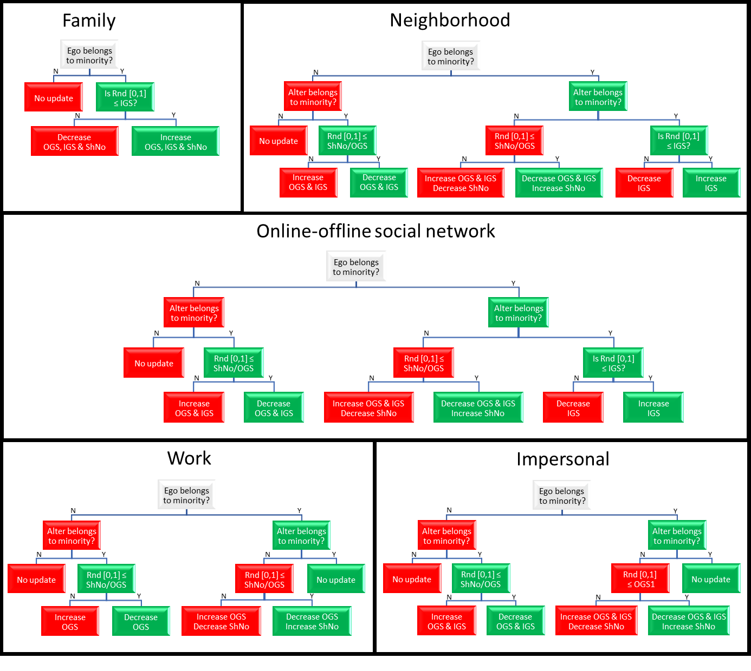

Figure : Decision trees for each type of dyadic interaction affecting the integration variables.

Rnd[0,1] is a random number drawn from an uniform distribution between [0,1]. IGS= in group support; OGS= out group suspicion; ShNo= shared norms.

***Cred displays***

All agents hold a WorldView (WV) variable ranging along a continuum between [0,1] that reflects the agents’ beliefs. Values < 0.5 reflect a secular (naturalistic) WV and values > 0.5 reflect a religious (super naturalist) WV. At initialization the value of the WV variable is determined by the openness personality trait of the agent. Values are drawn from a triangular distribution with mode = openness value and max/min equal to the mode +/- 0.25 (or 0 or 1). After initialization, and when agents are ≥ 12 years old, they hold weekly dyadic interactions in which one agent (the exemplar) displays a credibility enhancing display to another agent (the learner). The display may then increase of decrease the WV value of the learner agent. Displays can be positive (CRED) or negative (credibility undermining displays -CRUD-). The intensity and sign of the displays is given by the following equation.

**DTI = DISPLAYIMPORTANCE * DISPLAYIMPACT * DISPLAYCONSISTENCY**

Display total intensity (DTI) is an equation composed by three elements, display importance, impact and consistency. The value of DTI is a number in the continuum between [-1,1]. The value of each of the three elements is calculated based on the attributes of the learner and exemplar involved in the interaction as follows.

*DISPLAY IMPORTANCE = Leader of a club * WV Importance*

The element importance takes values between [0,1] and it is based on the attributes of the exemplar, i.e. the agent displaying the CRED. The first attribute represents whether the exemplar is the leader or not of a religious club. If the exemplar is not the leader of a club, then the variable takes a default value, 0.3. If the exemplar is the leader of a club, then the value taken by the variable depends on whether the exemplar is the leader of the club to which the learner is affiliated (if affiliated), global variable 50; or leader of a different club, global variable 49. The values of the global variable 49-50 have a min and max of 0.3-1.0 respectively. The second attribute reflect the WV value of the exemplar. Here, thus, we make a difference between the importance of secular and religious WV. The values taken by this variable are giving by the global variables 51-52 and range within the continuum [0.3-1.0].

*DISPLAY IMPACT* *= ExCharisma * LeSusceptibility * ClubCost * ClubImpact * Le-Ex Agediff * LeAge*

The element impact also takes values between [0,1] and it is based on attributes of the exemplar (*Ex* in equation) and leaner (*Le* in equation). *ExCharisma* takes the charisma personality trait value of the exemplar, thus the more charismatic the exemplar, the higher the impact of the display. *Lesusceptibility* takes the susceptibility personality trait value of the learner, thus the more susceptible the learner, the higher the impact of the display. If the exemplar is affiliated, then *ClubImpact* takes a value given by global variable 30 and *ClubCost* takes the cost value to the specific club to which the exemplar is affiliated. If the exemplar is not affiliated, the *ClubImpact* is set to a default value, 0.3; and *ClubCost* to the minimum club cost possible, given by global variable 81. When the exemplar is affiliated the min and max values of *ClubImpact* range within the continuum [0.3-1] and those of *ClubCost* within [global variable 81 – 1]. Thus, being affiliated always generates higher values for *ClubImpact* and *ClubCost* than being unaffiliated. The *Le-Ex Agediff* factor reflects the effect of age difference (between learner and exemplar) on the impact of the display. This effect is illustrated in figure 2.

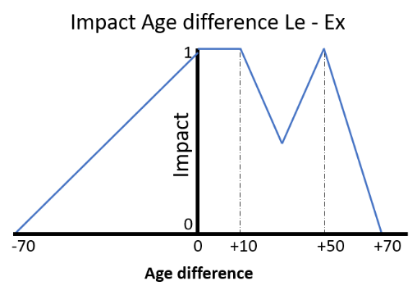

Figure : effect of age different on the CRED display impact

Taking the perspective of the leaner, when the exemplar is younger than the leaner (negative side of the x-axis), then the impact decreases linearly with increasing age difference. The impact is 1 when there is no age difference, and 0 when the exemplar is 70 years younger than the learner. On the other hand, when the learner is older than the exemplar (right side of the x-axis), then the impact is equal to 1 if the age difference is ≤ 10 years, then the impact decreases linearly to a minimum of 0.5 between (10-30] years difference; then it increases linearly to 1 with age difference between (30-50] to finally decrease linearly to 0 between (50-70] years old difference. The absolute age of the learner also influences the display impact according to figure 3.

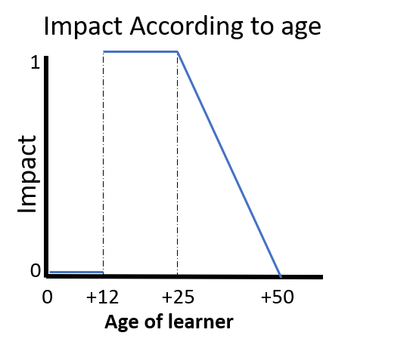

Figure : effect of learner’s age on the CRED display impact

Before 12 years old the impact is 0 because agents are not allowed to have interactions yet. From 12 to 25 years old the impact of the interaction is equal to 1. After 25 years old, the impact decreases linearly to 0 when agents become 50 years old. Above 50 years old thus, agents are not impacted by cred displays anymore and their WV values remain constant.

*DISPLAY CONSISTENCY = triangular (Mode, Min=Mode - Param†, Max= Mode + Param†)*

The element consistency ranges between [-1,1]. This is a value drawn from a triangular distribution with mode given by the following equation and error given by global variable 37.

$$Mode=2*\left(\left(1-e^{-α*ExCo}\right)* \left(1-e^{-β*(1-ExFr)}\right)*\left(1-\left(\frac{1}{1+e^{-γ*\left((1-ExWV)-θ\right)}}\right)\right)\right)-1$$

In the first two elements of the equation, *ExCo* and *ExFr*, take the values of the conscientiousness (*Co*) personality trait and frustration (*Fr*) variable of the learner. *α* and *β* determine the impact that *Co* and *Fr* have on the mode value respectively and are given by global variables 26-27. Because the (dis)affiliation processes seems sensitive to these parameters (see (dis)affiliation submodel), we restricted the range of these values to [0.5 – 9.0]. Within this range, the values taken by the first and second element of the equation depending on the values of *α* (or *β*) and conscientiousness (frustration) are given in figure 4.

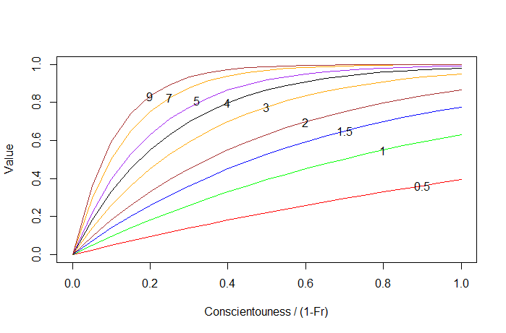

Figure : values (y-axis) taken by the first/second element of the mode equation according to different values of Co/Fr (x-axis) and α/β (values overlapping plot lines).

The third element of the equation is a sigmoidal curve reflecting the alignment between the exemplar’s WV value and its affiliation to a religious club. This element returns values > 0.5 if the (1 - *ExWV*) departs from the limit given by global variable 61 (default 0.5). In other words, when a secular exemplar (WV < 0.5) is affiliated to a religious club, 1 – *ExWV* will always be > 0.5 and the higher this departure the more likely the value return by the sigmoidal curve is ~1 (figure 5) and thus that the third the element of the equation becomes 0. The γ modulates the shape of the sigmoidal curve and in the simulation is was set to 20, global variable 28 (Figure 5).

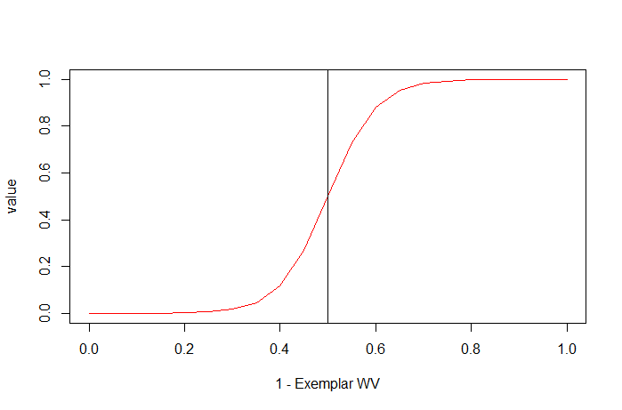

$$\left(\frac{1}{1+e^{-γ*\left((1-ExWV)-θ\right)}}\right)$$

Figure : values (y-axis) taken by third element of the mode equation when γ=20 and θ=0.5.

If the exemplar holds a secular WV but is affiliated to club, then 1 – ExWV > 0.5 and the equation will return high values.

Overall, the consistency element determines the sign of the display and whether this is taken as a CRED (positive sign) or as a CRUD (negative sign) by the learner. A CRUD is a “credibility undermining display” (Turpin, 2018). The chances of a display being a CRED increase when the exemplar conscientiousness is high, its frustration is low, and its WV aligns with the club, and vice versa, when the exemplar conscientiousness is low, its frustration is high, and belongs to a club that conflicts with its WV (a secular exemplar in a religious club), then the exemplar is more likely to send a CRUD than a CRED.

Besides the consistency element, which may turn CREDs into CRUDS, there is an extra process which may make learners interpret CREDs sent by others as CRUDs. This process happens only among secular people in our model, whom are likely to take religious CREDs as CRUDs. To simulate this, we implement an equation where the likelihood of interpreting a CRED as a CRUD depends on the degree of secularism of the learner. In other words, the more secular an agent the more likely to interpret a religious CRED as a CRUD. The process is illustrated in the pseudo-code below:

**double** rand = uniform(0,1);

**double** ProbCredToCrud = exp(-Parameter.CRED_to_CRUD * learner.WorldView ) * 0.9;

**if** (rand < ProbCredToCrud){ TDI = TDI * - 1.0;}

Where the probability of interpreting a CRED as a CRUD is given by a logarithmic distribution with *Parameter.CRED_to_CRUD* equal to global variable 24 and a max value of 0.9. In other words, even if the learner holds an extreme secular WV value (0), there will always be a 10% chance of keeping the CRED as CRED instead of interpreting it as a CRUD.

***Modulators of CRED displays’ intensity***

After the exemplar has displayed a CRED or a CRUD to the learner (see TDI equation above), there are other two factors which can further modulate the intensity of this display: a) Pluralism index and b) Existential security.

***Pluralism index***

The pluralism index represents the heterogeneity of WV values that an agent experiences in its close (family) and broader (neighborhood) environment. This index varies between [0,1] and is calculated as follows:

Pluralism Index = Q * ABS (EGO_WV – FAM_WV_AVE) + (1 – Q) * (ABS (EGO_WV – NEIGH_WV_AVE) )

The first element represents the deviation of the agent WV value (*EGO_WV*) from the average WV value of its family (*FAM_WV_AVE*) and the second element representing the deviation of the agent WV value from the average of WV value of its neighbourhood (*NEIGH_WV_AVE*). *Q* represents the weight (importance) given to the first element in relation to the second one and it is given by global variable 41. Index will be 0 (homogenous WV) when the WV value of the agent is exactly the same as that of the average of its family and neighbourhood and it will be 1 (heterogenous) when its completely the opposite of the average of its family and neighbourhood. The pluralism effect on the TDI is calculated as

Pluralism effect = 1 - (Pluralism Index / 2)

And this effect then affects the TDI by multiplying it,

TDI * Pluralism effect

Hence, a homogenous pluralism index (0) will have no effect on TDI since the pluralism effect will be equal to 1; an heterogenous index, on the other hand, will damp the TDI by a max of 50% when the pluralism index is highest, i.e. 1.

***Existential security***

Existential security may not only dampen but also enhance the intensity of the TDI. Importantly, this amplification/dampening effect will only occur on displays that are CREDs (but not CRUDs) and that come from religious exemplars. The existential security index ranges between [-0.5,0.5] and it is calculated as follows:

Existential security = ( HDIIncome_class + (ShNr – OGS) ) / 4

The equation is form by two elements, the income class adjusted by the Human development index of the society (global variable 47) and the second term represents the perceived threats by the agent reflected by the its shared norms (ShNr) value minus its out group suspicion value. The HDI dampens the effect of low income classes on existential security index. Thus, the effect of being in lowest or low income class is not the same when the agent is in a society with a high HDI (e.g. ~0.83, Norway) than in a society with a low HDI (~0.212, Central African Republic). In rich countries (high HDI) the effect of low income class is known to be different than in poor countries. We account for this in the following way. First, we assume that for agents in the highest income class category, the HDIIncome_class will always have a value of 0.999 no matter the HDI of the society. Then we adjust the values of the other income class categories according to the value of HDI of the society and the following linear equations.

If HDI > 0.5 { HDI_adjust = (1 - HDI) / 2; }

If HDI <= 0.5 { HDI_adjust = HDI / 2; }

Then we calculate the HDIincome_class value according to the following equations

LOWEST_CLASS) { HDI_Income = HDI - (2 * HDI_adjust); }

MIDDLE_LOW_CLASS { HDI_Income = HDI - HDI_adjust; }

MIDDLE_CLASS { HDI_Income = HDI; }

MIDDLE_HIGH_CLASS { HDI_Income = HDI + HDI_adjust; }

HIGHEST_CLASS { HDI_Income = 0.999; }

Figure 6 illustrates the values taken by the different income class categories at different HDI values according to the above equations.

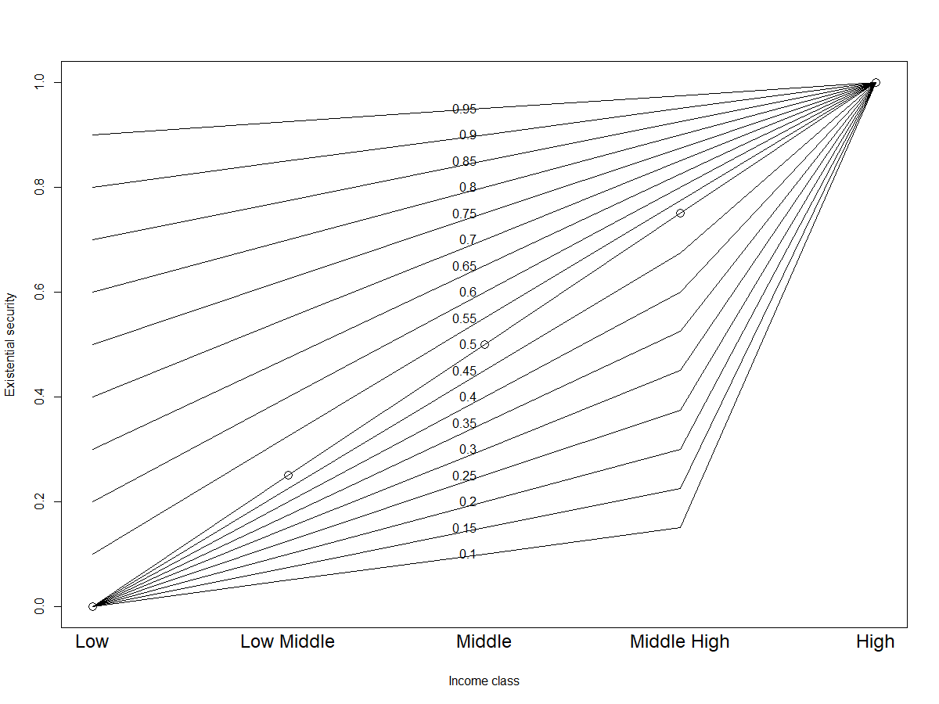

income class

HDI income class value

Figure : Values of HDIincome_class according to different HDI values (numbers overlapping plot lines) and income class category

Then we calculate the existential security effect on the TDI as follows

ES effect = 1 – Existential security index

And this ES effect then affects the TDI by multiplying it,

TDI * ES effect

Since the ES effect varies between [0.5,1.5] this means that at the lowest value of the existential security index, religious CREDs will be amplified by 50% and at the highest values of existential security religious CREDs will be damped by 50%.

***Effects of display on learner’s WV and Frustration variables.***

After the exemplar has displayed to the learner and the effects of all other factors on the TDI have been calculated; then, two variables of the learner, WV and Frustration, are updated according to the paths followed in a decision tree. Figures 7 and 8 illustrate the decision tree followed when the learners holds a secular (WV < 0.5) or a religious (WV > 0.5) worldview. Both decision trees consider whether the learner and/or exemplar are affiliated to a club, and the WV value of the exemplar. In addition, when the learner holds a religious WV, the decision tree considers whether the openness personality trait of the learner is high or low, and the type of religious club (majority/minority) the exemplar is affiliated to (fig 8). On the leaves of each tree is illustrated the effect that a CRED or a CRUD has on the world view and frustration variables of the learner. An up arrow means that the variable(s) increases and down arrow that the variable(s) decrease. The update of WV and frustration is then done as follow

*F(t+1) = F(t) +/- TDI (+/- sign depends on arrow direction, up (+) or down (-), fig 7-8)

WV(t+1) = W(t) +/- TDI (+/- sign depends on arrow direction, up (+) or down (-), fig 7-8)

*When according to the decision tree, the frustration of the learner increases, the increment in frustration is damped if the learner is affiliated to a club. This dampening effect is proportional to the degree of charisma of the leader of the club an calculated as follows

Leaders charisma effect = maximum of: 0.01 AND (1 - (Leader.Charisma / Global variable 29)

The leaders charisma effect the dampens the effect of TDI as follows:

F(t+1) = F(t) + (TDI * Leaders charisma effect)

Thus, the increase on frustration, TDI, may be dampened by a minimum of 1% and a maximum of 99 % when charisma of the leader is 0.99 and global variable 29 is 1.

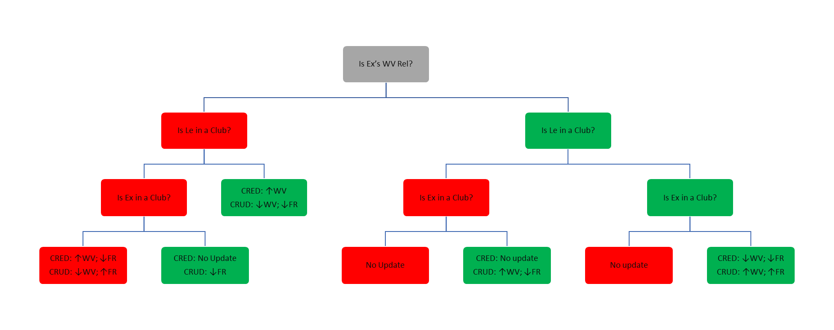

*Figure 7 decision tree followed when the leaners holds a secular WV (< 0.5).*

*Up arrows represent an increase and down arrows a decrease in the variable value.* *Red (left) = answer is No; Green (right) = answer is Yes.*

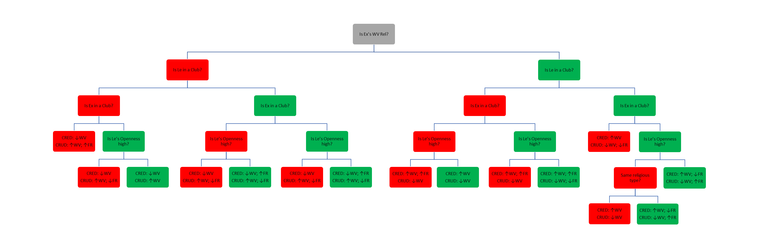

Figure 8 decision tree followed when the leaners holds a religious WV ( > 0.5).

Up arrows represent an increase and down arrows a decrease in the variable value. Red (left) = answer is No; Green (right) = answer is Yes.

***Club affiliation/deaffiliation***

The process of affiliation/deaffiliation to a club is determined by three different agent variables: Frustration, Motivation to join (MTJ), and Hypocrisy threshold (HT). At initialization and when new agents are born, the value of Frustration is drawn from a triangular distribution with mode = global variable 42 and +/- error = global variable 43. MTJ and HT are derived from the HEXACO personality traits as follows:

1. MTJ is a value drawn from a triangular distribution according to the following pseudo-code:

**double** AveEE = (Extraversion + Emotionality) / 2;

**double** minMTJ = Min_Join_Th; // global variable 76

**double** maxMTJ = 1.0;

**double** modeMTJ = minMTJ + ( (maxMTJ - minMTJ) * AveEE );

MTJ = triangular(minMTJ, maxMTJ, modeMTJ);

Where the minimum value of the triangular distribution is given by global variable 76, the maximum value is 1, and the mode is a value in between the min and max determined by the average of the agent’s emotionally and extraversion personality traits.

1. HT is also a value drawn from a triangular distribution according to the following pseudo-code:

**double** AveHC = (**this**.Honesty + **this**.Conscientiousness) / 2;

**double** minHT = Min_Hypoc_Th; // global variable 75

**double** maxHT = 1.0;

**double** modeHT = minHT + ( (maxHT - minHT) * AveHC );

HyprocrisyThreshold = triangular(minHT,maxHT,modeHT);

Where the minimum value of the triangular distribution is given by global variable 75, the maximum value is 1, and the mode is a value in between the min and max determined by the average of the agent’s honesty and conscientiousness personality traits.

Every week (time step) agents may affiliate/deaffiliate a club according to the following rules:

1. If the agent is affiliated:
   1. If agent’s Frustration > HT and Frustration < MTJ
      1. Agent leaves current club and remains unaffiliated
   2. If agent’s Frustration > HT and Frustration > MTJ
      1. Agent leaves current club and joins another one
2. If the agent is not affiliated:
   1. If agent’s Frustration > MTJ
      1. Agent joins a club

When the agent decides to join or switch a club, they choose one according to the following rules:

1. If WV > 0.5 agent looks for a religious club with same group identity (majority/minority)
   1. joins the club with last highest religious CRED it remembers according to its group identity, if no memory is available it joins a randomly selected club.
2. If WV < 0.5 (secular WV), the agent may join a religious club with probability given by the following pseudo code

DeviationFromMean = abs(WorldView - 0.5) / 0.5;

ProbJoinOppWVGroup = ( 1 * exp ( -lambda * DeviationFromMean ) );

**return** ProbJoinOppWVGroup;

Where the probability of joining a religious club when holding a secular WV is given by a logarithmic distribution with *lambda* equal to global variable 25. In other words, when the agent’s WV value is ~0.5, then, the chance of joining a religious club is ~1 and exponentially decreasing the more the WV of the agents moves away from 0.5. If on the basis of this probability, the agent decides to join a club then it joins the club with last highest religious CRED it remembers according to its group identity, if no memory is available it joins a randomly selected club

After the agent has gone through the processes of disaffiliating / reaffiliating a club, then their frustration is decreased by half to avoid repetition of the processes every week.

Memory of CREDS and CLUBS

Agents keep memory of the CRED with highest impact, this memory may be replaced when a new experienced CRED has higher impact than the one currently stored in memory. Memory of CRED are classified according to religious type (majority/minority). Thus, agents may hold up to two different memories of CREDs at any given time. Every week, the value of the CRED stored in memory decreases by 10 %.

**Table 1: Parameters values of the CRED model**

|  |  |  |
| --- | --- | --- |
| **Parameter** | **Value** | **Range** |
| *After marrying (same group identity marriages), probability of:* |  |  |
| Both agents remaining in the same situation (dis)affiliated to(from) a club | 0.2 | Fixed |
| Husband joining the club of his wife, if wife is in a club | 0.4 | Fixed |
| Husband disaffiliating from his club, if wife is in no club | 0.16 | Fixed |
| Husband remains in the same situation, if wife is in no club | 0.24 | Fixed |
| Wife joining the club of her husband, if husband is in a club | 0.4 | Fixed |
| Wife disaffiliating from her club, if husband is in no club | 0.16 | Fixed |
| Wife remains in the same situation, if husband is in no club | 0.24 | Fixed |
| *After marrying (inter-marriages), probability of:* |  |  |
| Both agents remaining in the same situation (dis)affiliated to(from) a club | 0.7 | Fixed |
| Husband joining the club of his wife, if wife is in a club | 0.15 | Fixed |
| Husband disaffiliating from his club, if wife is in no club | 0.06 | Fixed |
| Husband remains in the same situation, if wife is in no club | 0.09 | Fixed |
| Wife joining the club of her husband, if husband is in a club | 0.15 | Fixed |
| Wife disaffiliating from her club, if husband is in no club | 0.06 | Fixed |
| Wife remains in the same situation, if husband is in no club | 0.09 | Fixed |
| Agreeableness heritability | 0.33 | Fixed |
| Agreeableness mean | 0.5 | Fixed |
| Agreeableness standard deviation | 0.2 | Fixed |
| Authority impact | 0.1 | Fixed |
| Conscientiousness heritability | 0.5 | Fixed |
| Conscientiousness mean | 0.5 | Fixed |
| Conscientiousness standard deviation | 0.2 | Fixed |
| *Curve shape factors for:* |  | Fixed |
| Probability of interpreting a CRED as a CRUD | Not fixed | [1,40] |
| Probability of joining a religious club when holding a secular world view | Not fixed | [1,60] |
| Relation between conscientiousness and CRED consistency | Not fixed | [0.5,9] |
| Relation between values of frustration and CRED consistency | Not fixed | [0.5,9] |
| Relation between club and agent world view consistency | 20 | Fixed |
| Dampening effect of the leader of a club on the increase of an agent’s frustration | Not fixed | [1,10] |
| Effect of being affiliated to a club on CRED impact | Not fixed | [0.05,1] |
| Emotionality Heritability | 0.33 | Fixed |
| Emotionality Mean | 0.5 | Fixed |
| Emotionality SD | 0.2 | Fixed |
| Endogamy Degree | 0.95 | Fixed |
| Enforced Antidiscrimination | Not fixed | [0,0.9] |
| Error of display consistency of credibility enhancing display (CRED) | Not fixed | [0.25,0.75] |
| Extraversion Heritability | 0.5 | Fixed |
| Extraversion Mean | 0.5 | Fixed |
| Extraversion SD | 0.2 | Fixed |
| Family Impact on Pluralism Index | Not fixed | [0.1,1] |
| Frustration Mode | 0.5 | Fixed |
| Frustration range | 0.25 | Fixed |
| Honest Heritability | 0.31 | Fixed |
| Honesty Mean | 0.5 | Fixed |
| Honesty SD | 0.2 | Fixed |
| Human Development Index | Not fixed | [0.25,1] |
| Impersonal Radius | 50 | Fixed |
| Importance of a CRED being display by a leader of a given club | Not fixed | [0.05,1] |
| Importance of a CRED being display by a leader of my club | Not fixed | [0.05,1] |
| Importance of a CRED being display by a religious agent | Not fixed | [0.05,1] |
| Importance of a CRED being display by a secular agent | Not fixed | [0.05,1] |
| Income Median In Hundred Thousands | 0.35 | Fixed |
| Income Min In Hundred Thousands | 0.12 | Fixed |
| Income Skew In Hundred Thousands | 0.6 | Fixed |
| Ingroup Support Majority Mean | 0.5 | Fixed |
| Ingroup Support Majority SD | 0.25 | Fixed |
| Ingroup Support Minority Mean | 0.5 | Fixed |
| Ingroup Support Minority SD | 0.25 | Fixed |
| Interaction Radius | 50 | Fixed |
| Limit of the sigmoidal curve determining consistency of club / world view of agent | Not fixed | [0.4,0.6] |
| Marriage Age Tolerance | 2 | Fixed |
| Marriage Conversion Rate | 0.75 | Fixed |
| Marriage Education Tolerance | 2 | Fixed |
| Marriage Rate | 0.02 | Fixed |
| Max life expectancy majority | 90 | Fixed |
| Max life expectancy minority | 85 | Fixed |
| Max Number Of Children per couple | 5 | Fixed |
| Max years of education majority | 20 | Fixed |
| Max years of education minority | 20 | Fixed |
| Memory Decay Rate | 0.9 | Fixed |
| Min Age Marriage Majority | 26 | Fixed |
| Min Age Marriage Minority | 21 | Fixed |
| Min age to become leader of a club | 15 | Fixed |
| Min Hypocrisy Threshold | Not fixed | [0.5,0.9] |
| Min Join Threshold | Not fixed | [0.5,0.9] |
| Min life expectancy majority | 65 | Fixed |
| Min life expectancy minority | 45 | Fixed |
| Min years of education majority | 10 | Fixed |
| Min years of education minority | 12 | Fixed |
| Minimum Club Cost | 0.1 | Fixed |
| Minority Friendly mode | Not fixed | [0,0.9] |
| Nativity Cutoff | 10 | Fixed |
| Number of adults in initial population | Not fixed | [500-1000] |
| Number of clubs from majority | Not fixed | [5-15] |
| Number of clubs from minority | Not fixed | [5-15] |
| Number of Employers | Not fixed | [5,15] |
| Openness Heritability | 0.67 | Fixed |
| Openness Mean | 5 | Fixed |
| Openness SD | 0.2 | Fixed |
| Out group suspicion maj mean | 0.5 | Fixed |
| Out group suspicion maj SD | 0.25 | Fixed |
| Out group suspicion min mean | 0.5 | Fixed |
| Out group suspicion min sd | 0.25 | Fixed |
| Percentage of agents from the majority group in population | Not fixed | [0.6,0.9] |
| Percentage of Female agents | 0.52 | Fixed |
| Percentage of females from the majority employed | Not fixed | [0.75,0.95] |
| Percentage of females from the minority employed | Not fixed | [0.75,0.95] |
| Percentage of males from the majority employed | Not fixed | [0.75,0.95] |
| Percentage of males from the minority employed | Not fixed | [0.75,0.95] |
| Percentage of population not affiliated to a religious club | Not fixed | [0.1,0.9] |
| Probability of children joining the club (no club) of the mother | 0.9 | Fixed |
| Probability of losing employment majority | Not fixed | [0.05,0.15] |
| Probability of Meeting leader of my club | 5 | Fixed |
| Probability of sudden death (before life expectancy) | 0.005 | Fixed |
| Shared Norms Mean | 0.5 | Fixed |
| Shared Norms SD | 0.25 | Fixed |

# References: